**VPM's K.G. Joshi College of Arts and N.G. Bedekar College of Commerce (Autonomous), Thane**

**Activity Report**

**1. Title of the activity –वाचन संकल्प महाराष्ट्राचा**

**2. Name of the Departments - Department of Sanskrit**

**3. Day and Date - 1st January to 15th January 2025**

**4. Name of Resource Person - Sanskrit Department**

**5. No. of students benefited - Male -4 Female-14 Total-18**

**6. Purpose of the Activity:वाचन संकल्प महाराष्ट्राचा’; The वाचन संकल्प महाराष्ट्राचा (Reading Commitment Maharashtra) program, celebrated from 1st January to 15th January 2025, aims to promote the habit of reading and instill a sense of responsibility toward knowledge and learning. The purpose of this activity in the college is to encourage students, faculty, and the community to commit to regular reading, thus fostering a culture of intellectual growth and personal development.   Key purposes include:**

1. **Encouraging the Reading Habit  
    The program aims to inspire students to adopt reading as a regular practice, which can enhance their knowledge, vocabulary, and cognitive skills.**
2. **Celebrating Maharashtra's Literary Tradition  
    This initiative honors Maharashtra's rich literary heritage, including famous writers, poets, and thinkers. It also highlights the importance of regional literature in personal and educational growth.**
3. **Promoting Cultural Awareness  
    By involving students in reading books related to Maharashtra’s history, culture, and literature, the program creates an opportunity for students to understand and connect with the state's cultural roots.**
4. **Creating a Collective Commitment to Learning  
    The activity encourages not just individual reading, but also the formation of a collective commitment among students and faculty members to promote lifelong learning and knowledge-sharing.**
5. **Building Critical Thinking and Creativity  
    Reading diverse literature helps in developing critical thinking, creativity, and analytical skills. This activity offers a platform for students to reflect, discuss, and share their insights on what they have read.**
6. **Enhancing Community Engagement  
    Through group discussions, reading sessions, and collaborative events, the program promotes a sense of community where students, teachers, and parents are actively involved in promoting reading and intellectual conversations.**
7. **Gist of the Activity :- The वाचन संकल्प महाराष्ट्राचा program, held from 1st January to 15th January 2025, encourages students and the college community to commit to regular reading. The activity aims to promote the habit of reading, celebrate Maharashtra’s literary heritage, and foster intellectual growth. By engaging in discussions, reading sessions, and exploring regional literature, the program strengthens cultural awareness and a collective commitment to lifelong learning.**

**8. Teacher Incharge :-  Asst. Prof. Swati Bhalerao / Asst. Prof. Rohini Joshi**

**Thanks and Regards**

**Asst. Prof. Swati M. Bhalerao  Dr. Suchitra A. Naik**

**HoD Sanskrit Principal**

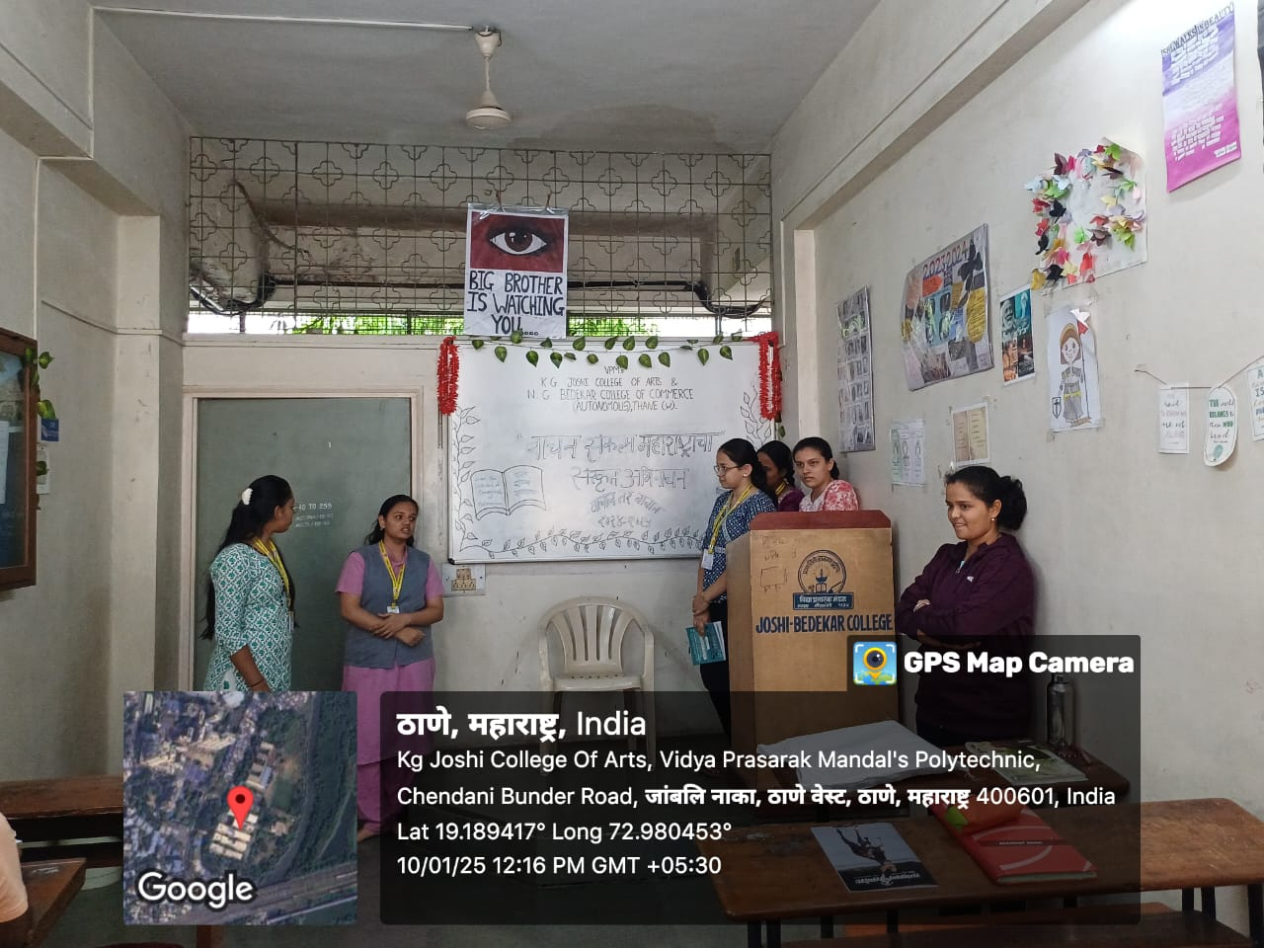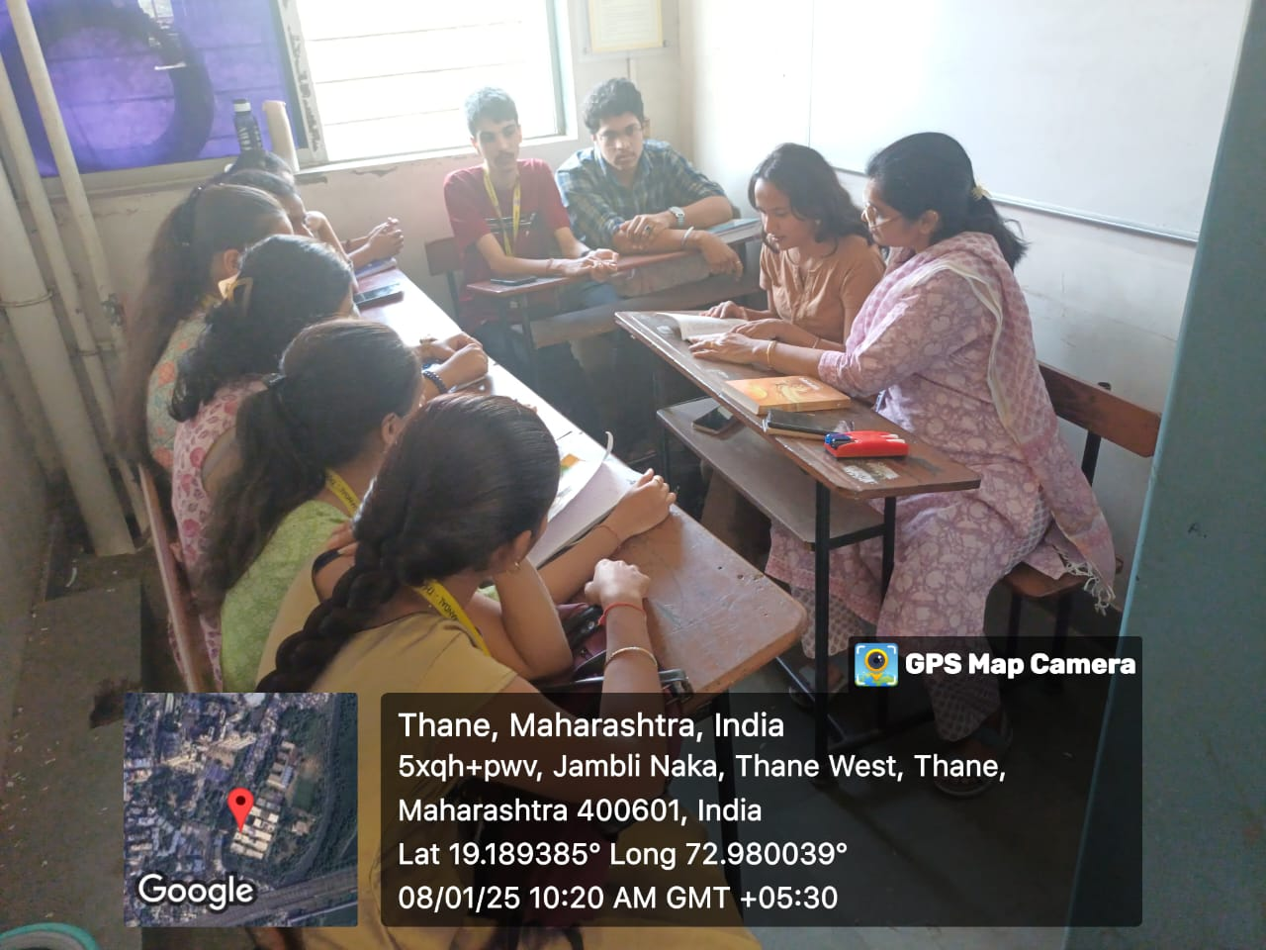

**वाचन संकल्प महाराष्ट्राचा  1st January to 15th January 2025**

**VPM's K.G. Joshi College of Arts and N.G. Bedekar College of Commerce (Autonomous), Thane**

**Activity Report**

**1. Title of the activity – Book Reading & Review**

**2. Name of the Departments - Department of Sanskrit**

**3. Day and Date - 10th January 2025 Friday**

**4. Name of Resource Person -**

**5. No. of students benefited - Male -4 Female-14 Total-18**

**6. Purpose of the Activity: Benefits:By conducting Book Reading & Review reading activity, educational institutions can promote academic excellence, cultural enrichment, and community engagement, ultimately inspiring a deeper appreciation for the languages and Indian heritage.**

**1. To help students understand and retain the material they are reading.**

**2. To develop vocabulary, grammar, and overall language proficiency.**

**3. Improved language skills.**

**4. To promote analysis, evaluation, and interpretation of the text.**

**5. To make reading a fun and enjoyable habit, cultivating a love for books and learning.**

**6. To expose readers to new ideas, perspectives, and information.**

**7. To develop skills necessary for academic success, like note-taking, summarizing, and discussing ideas.**

**8. To encourage discussion, collaboration, and exchange of ideas related to the reading material.**

**In summary, the purpose of reading activities is to strengthen both the technical skills involved in reading and the ability to engage deeply with content.**

**Outreach Opportunities:**

**7. Teacher Incharge :- Asst. Prof. Swati Bhalerao**

**Thanks and Regards**

**Asst. Prof. Swati M. Bhalerao  Dr. Suchitra A. Naik**

**HoD Sanskrit Principal**

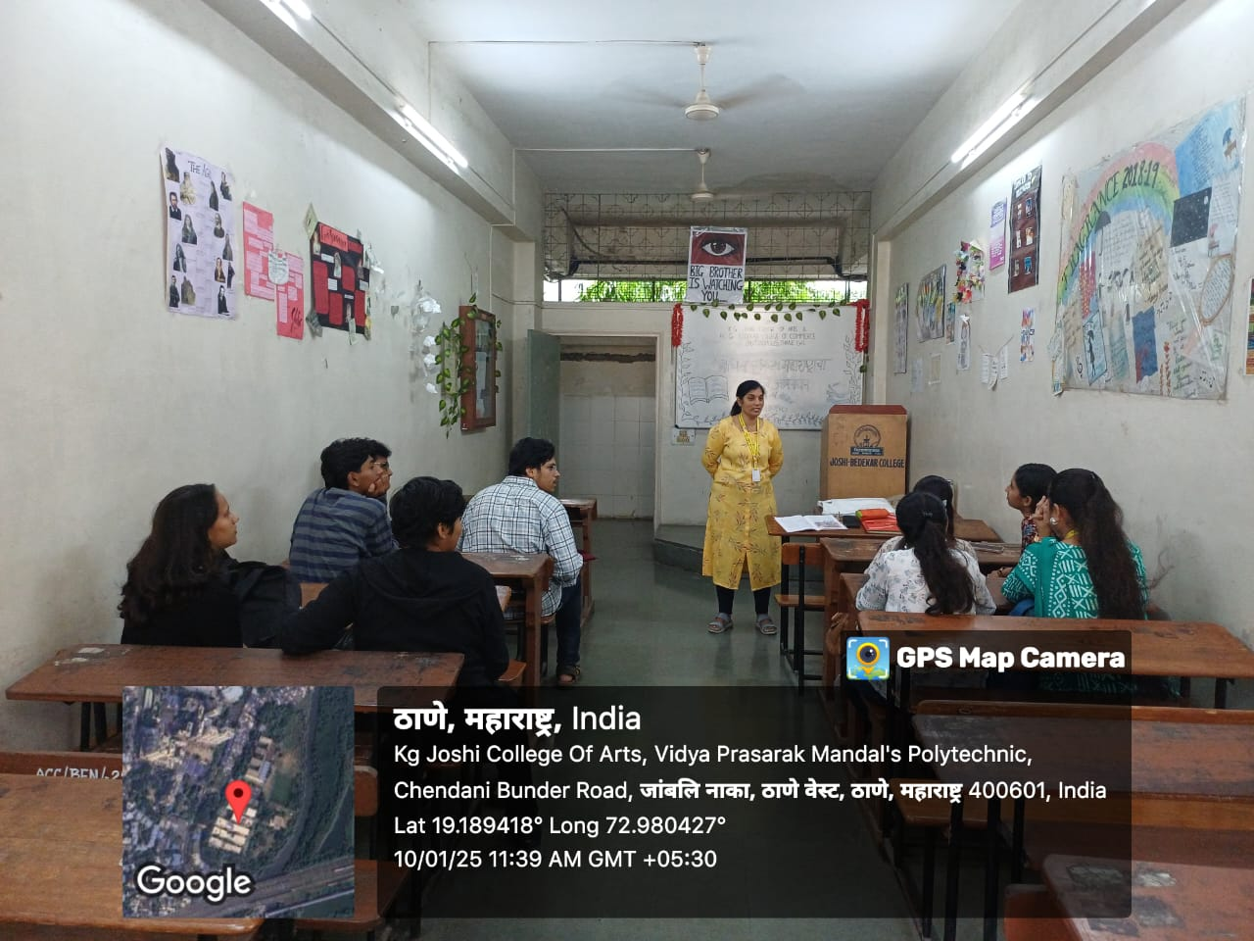

**Book Reading & Review  10th January 2025 Friday**